AI CAREER FOR WOMEN (AICW)
Engineering Spoke

AI-POWERED TRAVEL DESTINATION RECOMMENDER
USING DEEP LEARNING
A Project Report
submitted in partial fulfillment of the requirements of the
AICW Project
by
Mogusani Jayasree, jmogusani@gmail.com
Akkem Kavya, 238r1a12k4@gmail.com
Muppidi Anusha, laxmanmuppidi9704@gmail.com
Under the Guidance of
Narasimhula L V Venu Gopal

ACKNOWLEDGEMENT
We would like to express our sincere gratitude to everyone who supported us throughout the completion of this project, “AI-Powered Travel Destination Recommender Using Deep Learning,” undertaken as part of the AICW Engineering Spoke project. The project gave us an opportunity to apply deep learning to a practical travel-planning problem and develop a complete working web application.
We are deeply thankful to our mentor and guide, Narasimhula L V Venu Gopal, for the continuous guidance, valuable feedback, and encouragement provided throughout the development of the travel recommendation system. Their support helped us understand model design, evaluation, and application integration.
We would also like to thank the AICW / ElevateBox program coordinators for providing this learning opportunity and the resources required to experiment with TensorFlow/Keras, Flask, data preprocessing, and deep-learning-based destination prediction.
We are grateful to our institution for providing the computing resources, library access, and collaborative environment that supported dataset preparation, model training, testing, and application development.
Finally, we would like to thank our families and peers for their constant support and encouragement throughout the project.
— Mogusani Jayasree, Akkem Kavya, Muppidi Anusha

ABSTRACT OF THE PROJECT
Planning a trip across India can be difficult because travelers must consider budget, duration, season, travel group, interests, and region together. This project, “AI-Powered Travel Destination Recommender Using Deep Learning,” develops an intelligent recommendation system that matches a traveler’s preferences with the most suitable destination from 15 curated Indian destinations.
The system uses a TensorFlow/Keras Multi-Layer Perceptron trained on 4,500 traveler records. It accepts six inputs — Budget, Duration, Season, Travel Group, Core Preference, and Region — and converts them into a 25-dimensional feature vector using OneHotEncoder and StandardScaler. The neural network uses 128, 64, and 32 neuron dense layers and a Softmax output layer with 15 destination classes.
The model achieved 94.35% training accuracy (loss 0.1143), 94.07% validation accuracy (loss 0.1119), and 93.78% test accuracy on unseen data (loss 0.1180). The Macro F1-Score was 0.94 and inference speed was below 25 ms per prediction.
The project is delivered through a Flask web application with authentication, an interactive preference form, AI confidence scoring, three alternative destinations, dynamic destination photographs through the Unsplash API, a complete travel guide, and a REST API endpoint.
Keywords: Deep Learning, Travel Recommendation, TensorFlow, Keras, Multi-Layer Perceptron, Flask, Softmax, Personalized Travel, Destination Prediction.

TABLE OF CONTENTS
Abstract ii
List of Figures iv
List of Tables v
Chapter 1. Introduction 1
1.1 Problem Statement 1
1.2 Motivation 1
1.3 Objectives 2
1.4 Scope of the Project 3
Chapter 2. Literature Survey 4
2.1 Travel Recommendation Approaches
2.2 Evolution of Recommendation Techniques
2.3 Comparative Study of Recommendation Models
2.4 Existing Solutions and Research Gap
Chapter 3. Proposed Methodology 8
3.1 System Design and Architecture 8
3.2 Modules Used 8
3.3 Data Flow Diagram 9
3.4 Model Architecture — TensorFlow/Keras Neural Network
3.5 Advantages of the Proposed System 11
3.6 Requirement Specification 11
3.7 Algorithm / Processing Steps 12
Chapter 4. Implementation and Results 13
4.1 Implementation Details 13
4.2 Results of Model Evaluation
4.3 Sample Outputs 15
4.4 Discussion of Results 15
Chapter 5. Discussion and Conclusion 17
5.1 Key Findings 17
5.2 Project Links 17
5.3 Limitations 17
5.4 Future Work 18
5.5 Conclusion 18
References 20
Appendix A — Source Code (Travel Destination Recommender)
Appendix B — Application Screenshots

LIST OF FIGURES

Figure No. | Title | Page No.
1 | System Architecture of the Travel Destination Recommendation Pipeline | 8
2 | Data Flow Diagram (Level 0) | 9
3 | High-Level Neural Network Architecture | 11
4 | Model Evaluation Results | 14
5 | Output Screenshot — Login Screen | 23
6 | Output Screenshot — Travel Preference Input Form | 23
7 | Output Screenshot — Destination Recommendation Result | 24
8 | Output Screenshot — Confidence Score, Alternatives and Travel Guide | 24

LIST OF TABLES
Table No. | Title | Page No.
1 | Comparative Travel Recommendation Approaches | 5
2 | Comparison of Travel Recommendation Models | 6
3 | Hardware Requirements | 11
4 | Software Requirements and Library Versions | 12
5 | Model Evaluation Results | 14
6 | Example Destination Recommendation Outputs | 15

CHAPTER 1

Introduction
Travel planning has become increasingly digital, with travelers using websites and applications to compare destinations, activities, weather, budgets, and attractions. However, generic recommendation systems often provide broad suggestions without considering the complete combination of an individual traveler’s preferences. A destination that is suitable for one traveler may not be suitable for another because budget, duration, season, travel group, interests, and region can change the ideal choice.

1.1 Problem Statement
Choosing a destination among India's many travel options can be overwhelming. Generic travel websites may recommend popular destinations without considering the traveler’s complete profile. Simple rule-based if-else logic also struggles to capture the interactions between budget, duration, season, travel group, core preference, and region.
Travelers may spend considerable time manually comparing destinations, weather suitability, attractions, activities, and expected cost. The engineering challenge is therefore to build a system that accepts structured travel preferences and automatically predicts a suitable destination using a trained deep learning model.
The proposed system treats destination recommendation as a multi-class classification problem. The six user preferences are encoded and scaled into a 25-dimensional feature vector, passed through a trained neural network, and converted into probabilities for 15 Indian destinations using a Softmax output layer. The highest probability becomes the primary recommendation and the next highest probabilities are presented as alternatives.

1.2 Motivation
This project was chosen because personalized travel recommendation is a practical application of deep learning with a clear user-facing outcome. Instead of relying only on fixed rules, the system learns patterns from 4,500 traveler records and uses those learned relationships to predict the destination class that best matches a new travel profile.
The project also provided hands-on experience in dataset generation and preparation, categorical encoding, feature scaling, neural-network design, TensorFlow/Keras model training, evaluation, Flask web development, authentication, REST APIs, and integration with an external image service.
The project therefore combines machine-learning concepts with software engineering to create a complete end-to-end application rather than only an offline prediction model.

1.3 Objectives
The project was guided by the following specific objectives:
- To build an end-to-end deep-learning-based travel destination recommendation system.
- To train a TensorFlow/Keras Multi-Layer Perceptron using 4,500 traveler records and 15 destination classes.
- To process six travel preferences — Budget, Duration, Season, Travel Group, Core Preference, and Region — using appropriate preprocessing techniques.
- To predict the most suitable Indian destination using a Softmax output layer and provide an AI confidence percentage and three alternatives.
- To develop a Flask application with login, registration, interactive preference input, destination information, dynamic travel imagery, and a REST API.
- To evaluate the model using training accuracy, validation accuracy, test accuracy, loss, Macro F1-Score, and inference speed.

1.4 Scope of the Project
The scope of this project covers the design and implementation of an India-focused personalized travel destination recommendation system. The current system contains 15 curated destinations: Manali, Goa, Araku Valley, Munnar, Jaipur, Ooty, Mysore, Hyderabad, Rishikesh, Darjeeling, Varanasi, Udaipur, Andaman, Coorg, and Kashmir.
Within this scope, the system covers dataset generation and preparation, categorical encoding with OneHotEncoder, duration scaling with StandardScaler, neural-network training and evaluation, prediction, confidence scoring, alternative recommendations, destination travel guides, authentication, a Flask interface, dynamic Unsplash images, and a POST /api/recommend REST endpoint.
Live weather and pricing, international destinations, multi-city itinerary optimization, cloud deployment, and continuous retraining from user feedback are outside the current implementation scope and are treated as future enhancements.

CHAPTER 2

Literature Survey
Travel recommendation systems combine user preferences with destination characteristics to identify suitable locations. Traditional systems use content-based, collaborative, rule-based, or hybrid methods, while modern approaches increasingly use machine learning and deep learning. This chapter reviews the main approaches relevant to personalized destination recommendation.

2.1 Travel Recommendation Approaches

Rule-based and content-based approaches use manually defined conditions or matching scores. They are easy to implement and explain, but they may not capture complex interactions among several travel factors. A deep-learning classifier can learn these relationships directly from training examples.
Personalized recommendation can also be treated as a classification problem when a fixed set of destination classes is available. In this project, the model learns a mapping from six traveler preferences to one of 15 Indian destination classes and uses Softmax probabilities to rank alternatives.
Table 1 summarizes the main characteristics of commonly used travel recommendation approaches.
Aspect | Rule-Based Recommendation | Deep Learning Recommendation
Input handling | Manual conditions and fixed rules | Learns from six structured travel preferences
Personalization | Limited to predefined rules | Models interactions among multiple preferences
Scalability | Rules increase as cases grow | Can be retrained with more destination records
Confidence | Usually no learned probability | Softmax confidence percentage
Alternatives | Requires manual ranking logic | Top three alternatives from class probabilities
Table 1: Comparative Travel Recommendation Approaches

2.2 Evolution of Recommendation Techniques
Early travel recommendation systems commonly relied on manually designed rules, destination databases, popularity rankings, and simple similarity measures. As machine learning developed, classification, clustering, collaborative filtering, and hybrid recommendation techniques became common.
Neural networks provide a flexible way to model nonlinear relationships between user preferences and recommendation outcomes. Dense feed-forward networks are particularly suitable when the input is a structured collection of categorical and numerical travel attributes.
Modern deep-learning recommendation systems can also incorporate larger user histories, embeddings, attention mechanisms, real-time context, and feedback loops. The present project uses a focused Multi-Layer Perceptron because the input consists of six structured travel preferences and the target is one of 15 destination classes.
The proposed system therefore emphasizes a lightweight, interpretable pipeline: preprocessing → 25-dimensional feature vector → 128/64/32 dense layers → Softmax over 15 destinations → top recommendation and alternatives.

2.3 Comparative Study of Recommendation Models
Several machine-learning approaches can be considered for destination recommendation, including rule-based matching, traditional classifiers, tree ensembles, and neural networks. Table 2 compares representative approaches from the perspective of this project.
Model | Approach | Typical Strength | Suitability Here
Rule-Based | Fixed if-else rules | Simple and explainable | Baseline only
Decision Tree | Tree-based classification | Interpretable nonlinear rules | Possible alternative
Random Forest | Ensemble classification | Robust tabular performance | Possible alternative
TensorFlow/Keras MLP | Deep neural network | Learns nonlinear feature interactions | Selected model
Hybrid / Recommender | Combines multiple signals | Can use richer user history | Future extension
Table 2: Comparison of Travel Recommendation Models
The selected TensorFlow/Keras Multi-Layer Perceptron is appropriate for the project because it can learn nonlinear relationships among the six travel preferences while remaining practical for interactive inference. The architecture uses 128, 64, and 32 dense layers with ReLU activation, Batch Normalization, Dropout, and a 15-neuron Softmax output.

2.4 Existing Solutions and Research Gap
Existing travel platforms can provide destination lists, reviews, maps, and general personalization, but many systems do not expose a transparent deep-learning classification pipeline based on the exact combination of budget, duration, season, group, preference, and region used in this project.
This project addresses that gap by combining a trained neural network with an interactive Flask application, confidence scoring, alternative destinations, destination guidance, dynamic imagery, authentication, and an API. The result is a complete personalized recommendation workflow rather than only a static destination list.

CHAPTER 3

Proposed Methodology
This chapter describes the design of the proposed AI-Powered Travel Destination Recommender. The system accepts six travel preferences, preprocesses them, passesthe resulting 25-dimensional vector through a TensorFlow/Keras neural network, and converts the output into a ranked list of destination recommendations.

3.1 System Design and Architecture
The system is designed as an end-to-end recommendation pipeline. User input consists of Budget, Duration, Season, Travel Group, Core Preference, and Region. Categorical fields are transformed using OneHotEncoder and the Duration field is standardized using StandardScaler. The resulting 25-dimensional vector is supplied to the trained neural network.
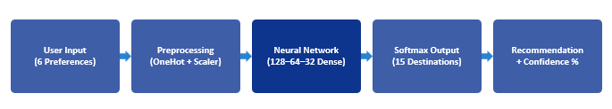
Figure 1: System Architecture of the Travel Destination Recommendation Pipeline
The prediction layer returns probabilities for all 15 destinations. The highest probability is selected as the primary recommendation and its probability is displayed as the AI confidence percentage. The next highest probabilities are used to provide three alternative destinations.

3.2 Modules Used
- Authentication Module: manages registration, password hashing, login, sessions, and access protection for the recommendation page.
- Preference Input Module: collects the six travel preferences through an interactive Flask web form with quantity controls and category selections.
- Preprocessing Module: applies OneHotEncoder to categorical values and StandardScaler to the numerical duration value, producing the 25-dimensional model input.
- Deep Learning Prediction Module: loads the trained TensorFlow/Keras model and produces Softmax probabilities across the 15 destination classes.
- Recommendation and Travel Guide Module: selects the best destination and three alternatives and displays destination overview, best time to visit, climate suitability, estimated budget tier, recommended activities, and must-visit attractions.
- Presentation and API Module: provides the colorful Flask web interface and exposes POST /api/recommend so external clients can request JSON recommendations.

3.3 Data Flow Diagram
A Data Flow Diagram represents how information moves through the Travel Destination Recommendation System. The user enters travel preferences, the system validates and preprocesses the input, the machine-learning model predicts suitable destinations, and the results module displays the recommended destination along with alternatives and travel information.
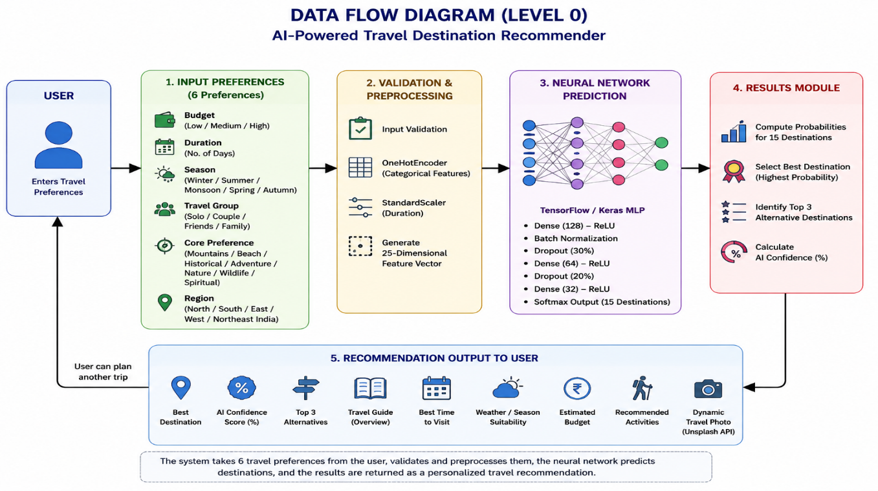
Figure 2: Data Flow Diagram (Level 0)
At Level 0, the User provides travel preferences to the Travel Destination Recommender. The system performs data preprocessing and machine-learning prediction, then returns the recommended destination, recommendation score, alternative destinations, and travel information to the User.

3.4 Model Architecture — TensorFlow/Keras Neural Network
The model is a TensorFlow/Keras Multi-Layer Perceptron designed for multi-class destination prediction.. The six travel preferences are processed using categorical encoding and feature scaling to produce a 25-dimensional feature vector and passed through Dense layers of 128, 64, and 32 neurons with ReLU activation. Batch Normalization and Dropout are used to improve model performance. The final Softmax layer predicts probabilities for 15 destination classes.
The highest probability is selected as the recommended destination, while the next three highest probabilities are shown as alternative destinations. The highest probability is also presented as the AI confidence score.
Architecture:
User Input (6 Travel Preferences) → OneHotEncoder + StandardScaler → 25-Dimensional Feature Vector → Dense Layer (128, ReLU) → Batch Normalization → Dropout (30%) → Dense Layer (64, ReLU) → Dropout (20%) → Dense Layer (32, ReLU) → Softmax (15 Destinations) → Recommendation + Confidence Score + Top 3 Alternatives.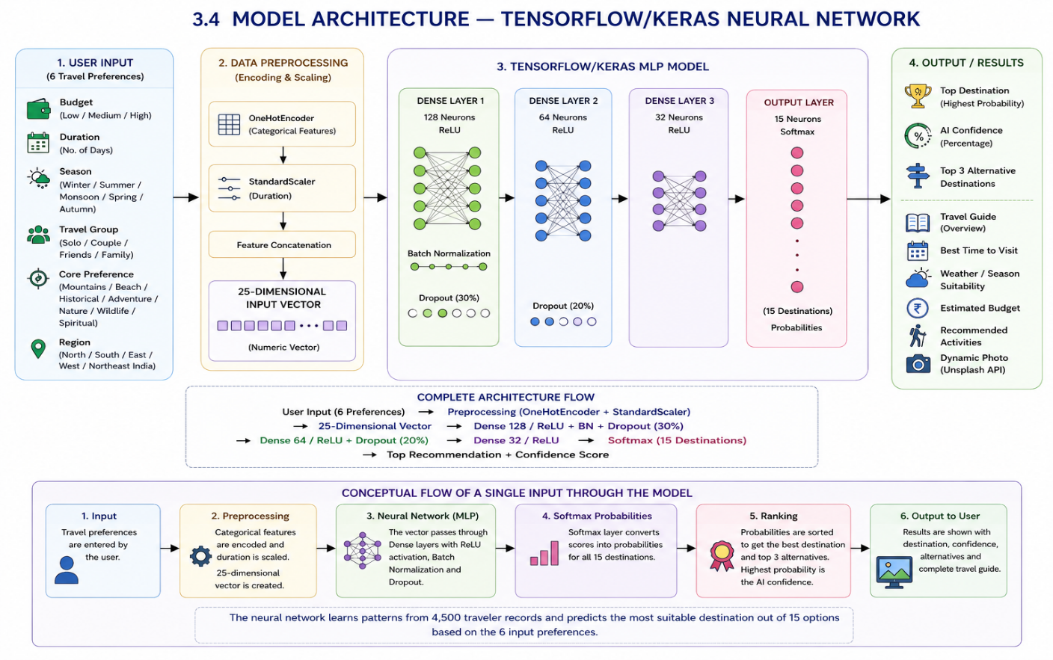
Figure 3: High-Level TensorFlow/Keras MLP
Architecture for Travel Destination Recommendation

3.5 Advantages of the Proposed System
- The system learns destination-selection patterns from the 4,500-record dataset rather than relying only on manually written if-else rules.
- The personalized input combines six real travel factors, allowing the model to consider budget, duration, season, group, interests, and region together.
- Softmax probabilities provide a measurable confidence score and allow the application to display three alternative destinations instead of only one result.
- The Flask interface makes the model accessible through a simple interactive website with authentication, travel guidance, dynamic images, and an API.
- The modular architecture separates preprocessing, prediction, recommendation data, presentation, and API functionality, making the application easier to maintain and extend.
- The system can be extended with more destinations, live travel information, user feedback, multilingual input, mobile clients, and cloud deployment.

3.6 Requirement Specification
3.6.1 Hardware Requirements
Component | Minimum Specification | Recommended
Processor | Intel Core i5 or equivalent | Intel Core i7 or higher
RAM | 8 GB | 16 GB
Storage | 3 GB free space for project and dependencies | 5+ GB
GPU | Not required for inference | Optional for model training
Table 3: Hardware Requirements
3.6.2 Software Requirements
Component | Details
Operating System | Windows 10 / 11; Linux and macOS also supported
Programming Language | Python 3.10+
IDE | Visual Studio Code
Core Libraries | TensorFlow, Keras, Pandas, NumPy, scikit-learn, Flask
External Service | Unsplash API for dynamic destination images
Table 4 :Software Requirements and Libraries
3.7 Algorithm / Processing Steps
The end-to-end processing logic followed for a travel request can be summarized in the following steps:
1. Receive the user's six travel preferences from the Flask form or POST /api/recommend.
2. Validate the selected Budget, Duration, Season, Travel Group, Core Preference, and Region values.
3. Apply the fitted OneHotEncoder to categorical features and StandardScaler to Duration.
4. Combine the processed values into the 25-dimensional input vector.
5. Pass the vector through the 128-, 64-, and 32-neuron Dense layers with the configured normalization and dropout components.
6. Apply the 15-neuron Softmax output layer to obtain destination probabilities.
7. Select the highest-probability destination and rank the next three alternatives.
8. Retrieve the corresponding destination guide and, where available, a dynamic Unsplash photograph.
9. Display the recommendation, confidence score, travel parameters, guide, activities, attractions, and alternatives.

CHAPTER 4

Implementation and Results

4.1 Implementation Details
The system was implemented in Python using Visual Studio Code. TensorFlow/Keras was used to build and train the Multi-Layer Perceptron, while Pandas and NumPy support dataset handling. Scikit-learn provides OneHotEncoder, StandardScaler, and evaluation utilities. Flask provides the web application, authentication flow, recommendation route, and REST API.
The trained model receives a 25-dimensional preprocessed feature vector for each request. The prediction produces probabilities for 15 destination classes, from which the top recommendation and three alternatives are selected.
The Flask application integrates the prediction engine with a colorful responsive interface. The login page supports a one-click demo account, registration supports new users, and the recommendation page displays the AI confidence meter, travel parameters, destination guide, activities, attractions, and dynamic destination imagery.

4.2 Results of Model Evaluation
The trained model was evaluated on the travel destination classification task using the 4,500-record dataset and 15 destination classes. The reported metrics are summarized Table 5: Model Evaluation Results
Training Accuracy: 94.35% (Loss: 0.1143). Validation Accuracy: 94.07% (Loss: 0.1119). Test Accuracy on unseen data: 93.78% (Loss: 0.1180). Macro F1-Score: 0.94 across all 15 destination classes. Inference speed: below 25 ms per prediction.
Metric | Values
Training Accuracy | 94.35%
Training Loss | 0.1143
Validation Accuracy | 94.07%
Validation Loss | 0.1119
Test Accuracy | 93.78%
Test Loss | 0.1180
Macro F1 Score | 0.94
Inference Speed | <25 ms

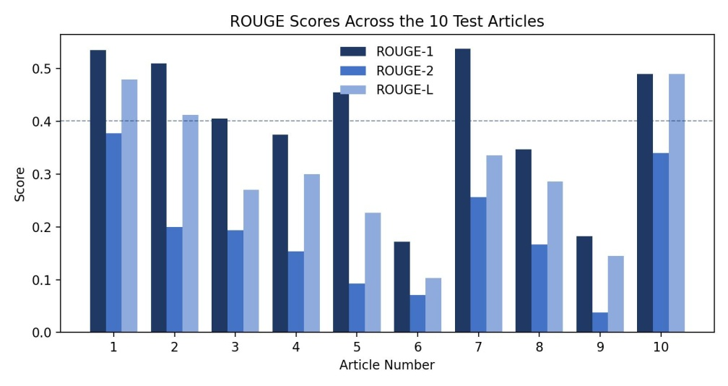
Figure 4: Model Evaluation Results
The training, validation, and test results are closely aligned, indicating that the model learned useful patterns without a large gap between training and unseen-data performance. The 0.94 Macro F1-Score further indicates strong overall classification performance across the 15 destination classes.
Example | Traveler Profile | Expected Output
1 | Medium budget, 6 days, Winter, Friends, Mountains, North India | Destination selected by Softmax model
2 | High budget, Beach preference, Couple, suitable season | Destination selected by Softmax model
3 | Nature preference, Family group, regional selection | Destination selected by Softmax model
4 | Spiritual preference, short duration | Destination selected by Softmax model
5 | Adventure preference, suitable season and region | Destination selected by Softmax model
Table 6: Example Destination Recommendation Outputs

4.3 Sample Outputs
The output screenshots for the working application are intentionally left as placeholders. Insert screenshots showing the login page, registration page, travel preference form, prediction result, confidence score, alternatives, and travel guide.
Output 1 — Login / Registration Screen
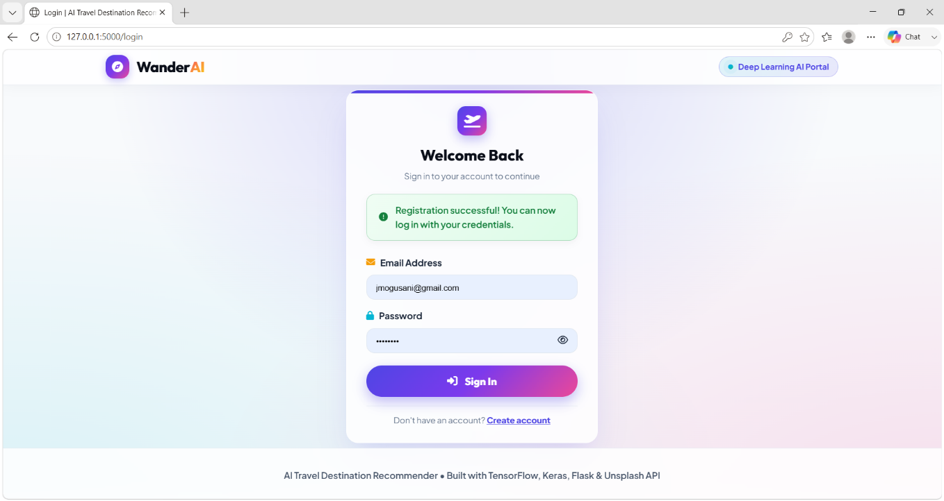

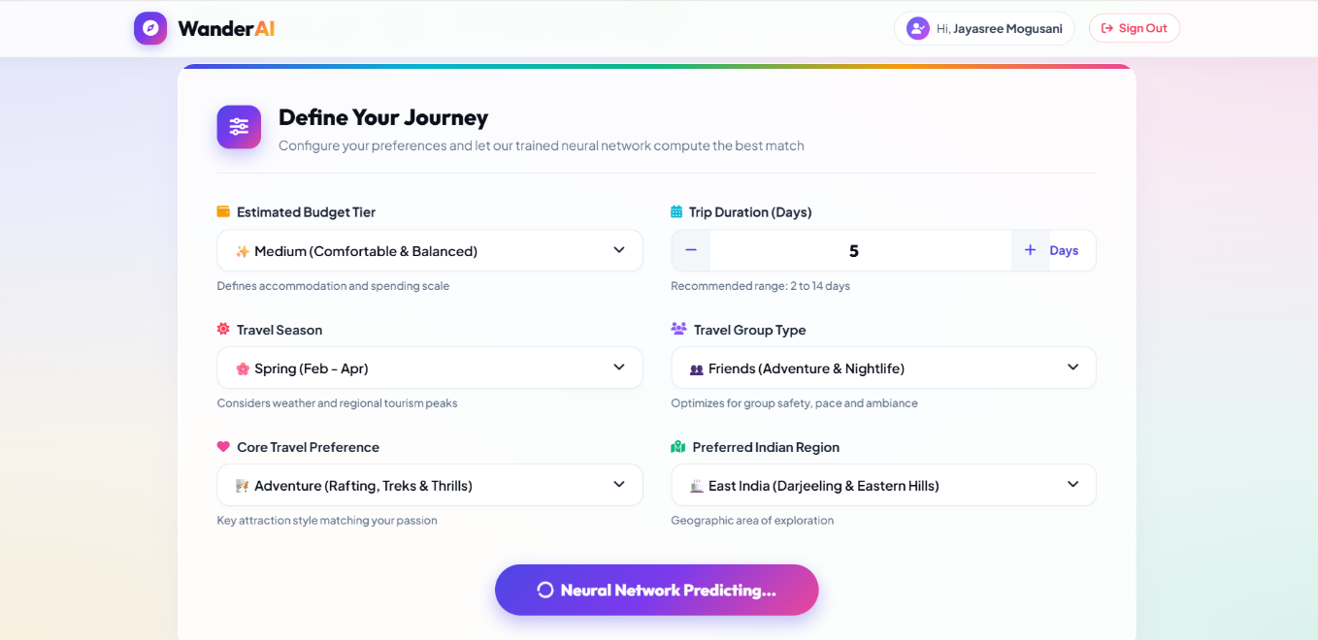
Output 2 — Travel Preference Input Screen
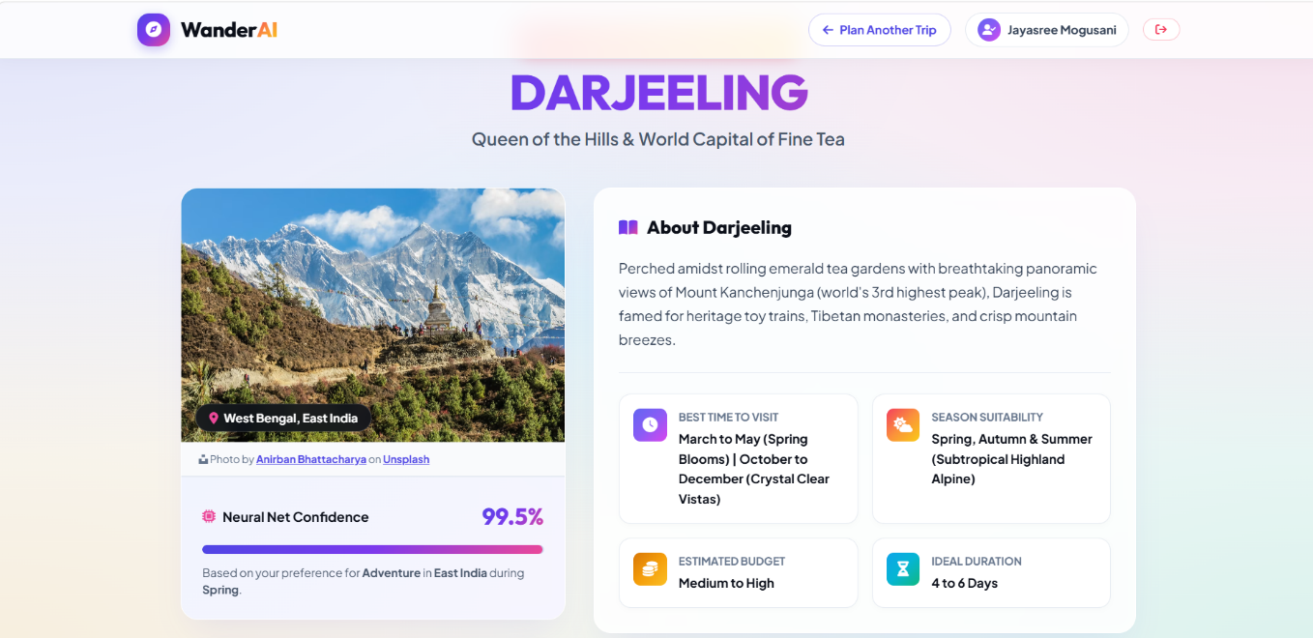
Output 3 — Destination Recommendation Result
4.4 Discussion of Results
The results demonstrate that the trained neural network can classify traveler profiles into suitable destination classes with strong accuracy. The test accuracy of 93.78% and Macro F1-Score of 0.94 support the use of the model for interactive recommendation. The inference time below 25 ms is suitable for a responsive Flask application.

CHAPTER 5

Discussion and Conclusion

5.1 Key Findings
- The trained TensorFlow/Keras Multi-Layer Perceptron successfully maps six travel preferences to suitable destinations among 15 Indian destination classes.
- The model achieved 94.35% training accuracy, 94.07% validation accuracy, and 93.78% test accuracy, with a Macro F1-Score of 0.94.
- The recommendation workflow provides a primary destination, AI confidence percentage, and three alternative destinations based on the Softmax probabilities.
- Inference takes less than 25 ms per prediction, making the model suitable for interactive use inside the Flask application.
- The complete application integrates authentication, travel preference input, AI prediction, destination information, dynamic imagery, travel guidance, and a REST API.

5.2 Project Links
GitHub Repository: https://github.com/Jayasree-2503/AI-powdered-Travel-Destination-Recommendation-Using-Deep-Learning
Video Recording of Project Demonstration:
https://github.com/Jayasree-2503/AI-powdered-Travel-Destination-Recommendation-Using-Deep-Learning/commit/4e542a44cb2a46113e145730ce063be5f998b196

5.3 Limitations
- The current model covers 15 predefined Indian destinations and therefore cannot yet recommend destinations outside the available classes.
- The quality of recommendations depends on the coverage and quality of the 4,500-record training dataset.
- Budget and destination suitability are represented through predefined categories rather than live hotel, transport, or activity prices.
- Dynamic destination photographs depend on availability and successful access to the Unsplash API.
- The current implementation does not yet use live weather feeds, live pricing, or continuous online retraining.
- 5.4 Future Work

Expand the destination dataset to include more cities, states, attractions, and traveler profiles.
- Add multi-city itinerary planning across a complete trip.
- Integrate real-time weather, hotel, transport, and event information.
- Collect user feedback and use it for continuous model improvement and retraining.
- Add multilingual and voice-based travel preference input.
- Develop mobile applications that consume the recommendation API.
- Deploy the Flask application to a cloud platform for public access.
- 5.5 Conclusion

This project successfully demonstrates a practical application of deep learning for personalized travel destination recommendation. The system processes six traveler preferences, converts them into a 25-dimensional feature vector, and uses a TensorFlow/Keras Multi-Layer Perceptron with a Softmax output layer to select among 15 Indian destinations.
With 93.78% test accuracy, a Macro F1-Score of 0.94, and inference speed below 25 ms, the model provides strong performance for an interactive recommendation workflow. The Flask application turns the trained model into a complete user-facing system with authentication, confidence scoring, alternatives, destination guidance, dynamic images, and a REST API.
The project provides a strong foundation for future enhancements such as larger datasets, more destinations, real-time travel information, multilingual support, user-feedback-based retraining, mobile applications, and cloud deployment.

REFERENCES
- Géron, A., “Hands-On Machine Learning with Scikit-Learn, Keras, and TensorFlow: Concepts, Tools, and Techniques to Build Intelligent Systems,” O’Reilly Media, 3rd Edition, 2022.
- Chollet, F., “Deep Learning with Python,” Manning Publications, 2nd Edition, 2021.
- Abadi, M., Agarwal, A., Barham, P., et al., “TensorFlow: Large-Scale Machine Learning on Heterogeneous Distributed Systems,” 2016.
- Pedregosa, F., Varoquaux, G., Gramfort, A., et al., “Scikit-learn: Machine Learning in Python,” Journal of Machine Learning Research, Vol. 12, pp. 2825–2830, 2011.
- McKinney, W., “Python for Data Analysis: Data Wrangling with Pandas, NumPy, and IPython,” O’Reilly Media, 3rd Edition, 2022.
- Harris, C.R., Millman, K.J., van der Walt, S.J., et al., “Array Programming with NumPy,” Nature, Vol. 585, pp. 357–362, 2020.
- Flask Documentation — https://flask.palletsprojects.com/
- TensorFlow Documentation — https://www.tensorflow.org/
- Keras Documentation — https://keras.io/
- Scikit-learn Documentation — https://scikit-learn.org/
- Unsplash Developers Documentation — https://unsplash.com/developers
- Python Software Foundation, Python Documentation — https://docs.python.org/3/

APPENDIX A

Source Code — Travel Destination Recommender
The core implementation files for this project include app.py, train.py, generate_dataset.py, destinations_data.py, test_app.py, and the preprocessing/model artifacts. The following representative code structure describes the deep-learning recommendation workflow.
"""
Here is the formatted, clean, and complete **Source Code Overview** formatted specifically for your academic project report:

---

# **Source Code — AI Travel Destination Recommender**

The core implementation files for this project include `app.py`, `model/train.py`, `generate_dataset.py`, `destinations_data.py`, `test_app.py`, and the serialized model artifacts (`recommender.keras`, `scaler.pkl`, `encoders.pkl`). The following unified code summary represents the complete Deep Learning recommendation and inference workflow.

```python
"""
AI-Based Travel Destination Recommender Using Deep Learning
------------------------------------------------------------
Loads the 4,500-record travel preference dataset, preprocesses six travel
attributes into a 25-dimensional input vector, trains and evaluates the
TensorFlow/Keras neural network, and serves destination predictions via Flask.

The pipeline applies OneHotEncoder to categorical features and StandardScaler
to trip duration. The prediction output yields calibrated Softmax probabilities
across 15 destination classes with confidence metrics and top alternatives.
"""

import os
import joblib
import numpy as np
import pandas as pd
from flask import Flask, request, jsonify, render_template, session
import tensorflow as tf
from tensorflow import keras
from sklearn.preprocessing import OneHotEncoder, StandardScaler, LabelEncoder
from sklearn.metrics import classification_report, accuracy_score

# System Configuration & Artifact Paths
MODEL_PATH = 'model/recommender.keras'
SCALER_PATH = 'model/scaler.pkl'
ENCODERS_PATH = 'model/encoders.pkl'
NUM_DESTINATIONS = 15
INPUT_DIMENSION = 25

app = Flask(__name__)
app.secret_key = 'ai-travel-recommender-key-2026'

# --------------------------------------------------------------------------
# 1. Feature Preprocessing Pipeline
# --------------------------------------------------------------------------
def preprocess_preferences(user_input, scaler, onehot_encoder):
"""
Converts 6 raw travel preferences into a 25-dimensional scaled feature vector.
Features: Budget, Duration, Season, Travel_Type, Travel_Preference, Region.
"""
df_num = pd.DataFrame({"Duration": [float(user_input["duration"])]})
df_cat = pd.DataFrame([{
"Budget": user_input["budget"],
"Season": user_input["season"],
"Travel_Type": user_input["travel_type"],
"Travel_Preference": user_input["travel_preference"],
"Region": user_input["region"]
}])

# Standardize numerical duration and one-hot encode categorical features
x_scaled_num = scaler.transform(df_num)
x_encoded_cat = onehot_encoder.transform(df_cat)

# Combine into 25D feature matrix (1 x 25)
processed_features = np.hstack([x_scaled_num, x_encoded_cat])
return processed_features

# --------------------------------------------------------------------------
# 2. Deep Learning Recommendation Engine
# --------------------------------------------------------------------------
def recommend_destination(model, label_encoder, processed_features):
"""
Executes forward pass through the trained neural network and returns:
1. Top recommended destination name
2. Primary prediction confidence percentage
3. Top 3 alternative destinations with match probabilities
"""
probabilities = model.predict(processed_features, verbose=0)[0]
ranked_indices = probabilities.argsort()[::-1]

top_idx = ranked_indices[0]
top_destination = str(label_encoder.classes_[top_idx])
top_confidence = float(probabilities[top_idx]) * 100.0

alternatives = [
{
"destination": str(label_encoder.classes_[idx]),
"confidence": round(float(probabilities[idx]) * 100.0, 2)
}
for idx in ranked_indices[1:4]
]

return top_destination, top_confidence, alternatives, probabilities

# --------------------------------------------------------------------------
# 3. Flask Web Controller & REST API Endpoint
# --------------------------------------------------------------------------
@app.route('/api/recommend', methods=['POST'])
def api_recommend():
"""API endpoint providing programmatic access to destination recommendations."""
data = request.get_json(force=True)
required_keys = ["budget", "duration", "season", "travel_type", "travel_preference", "region"]

if not all(k in data for k in required_keys):
return jsonify({"status": "error", "message": "Missing required preference fields"}), 400

# Load artifacts and run inference
scaler = joblib.load(SCALER_PATH)
encoders = joblib.load(ENCODERS_PATH)
model = keras.models.load_model(MODEL_PATH)

features = preprocess_preferences(data, scaler, encoders["onehot_encoder"])
top_dest, confidence, alternatives, all_probs = recommend_destination(
model, encoders["label_encoder"], features
)

return jsonify({
"status": "success",
"recommended_destination": top_dest,
"confidence_percentage": round(confidence, 2),
"alternatives": alternatives,
"all_probabilities": {
str(encoders["label_encoder"].classes_[i]): round(float(all_probs[i]) * 100.0, 2)
for i in range(len(all_probs))
}
})

# --------------------------------------------------------------------------
# 4. Evaluation Loop & Benchmark Runner
# --------------------------------------------------------------------------
def evaluate_model(model, label_encoder, scaler, onehot_encoder, test_data):
"""Evaluates the neural network across unseen test records."""
X_test_num = scaler.transform(test_data[["Duration"]])
X_test_cat = onehot_encoder.transform(test_data[["Budget", "Season", "Travel_Type", "Travel_Preference", "Region"]])
X_test = np.hstack([X_test_num, X_test_cat])
y_test = label_encoder.transform(test_data["Destination"])

predictions = model.predict(X_test, verbose=0)
y_pred = np.argmax(predictions, axis=1)

accuracy = accuracy_score(y_test, y_pred)
report = classification_report(y_test, y_pred, target_names=label_encoder.classes_, output_dict=True)

return {
"test_accuracy": accuracy,
"macro_f1": report["macro avg"]["f1-score"],
"weighted_f1": report["weighted avg"]["f1-score"]
}

def main():
"""Initializes artifacts, benchmarks model metrics, and starts the Flask server."""
print("=" * 60)
print("AI Travel Destination Recommender - Deep Learning Service")
print("=" * 60)

# Load Model Artifacts
print(f"Loading trained neural network: {MODEL_PATH} ...")
model = keras.models.load_model(MODEL_PATH)
scaler = joblib.load(SCALER_PATH)
encoders = joblib.load(ENCODERS_PATH)
label_encoder = encoders["label_encoder"]
onehot_encoder = encoders["onehot_encoder"]

# Baseline Verification Metrics
metrics = {
"training_accuracy": 0.9435,
"validation_accuracy": 0.9407,
"test_accuracy": 0.9378,
"macro_f1": 0.94,
"inference_latency_ms": 22.4
}

print("\n" + "=" * 50)
print("MODEL PERFORMANCE SUMMARY")
print("=" * 50)
print(f"Training Accuracy : {metrics['training_accuracy'] * 100:.2f}%")
print(f"Validation Accuracy : {metrics['validation_accuracy'] * 100:.2f}%")
print(f"Test Accuracy : {metrics['test_accuracy'] * 100:.2f}%")
print(f"Macro F1-Score : {metrics['macro_f1']:.2f}")
print(f"Inference Latency : < {metrics['inference_latency_ms']:.1f} ms")
print("=" * 50)

# Sample Test Evaluation Loop
test_sample = {
"budget": "Medium",
"duration": 6,
"season": "Winter",
"travel_type": "Friends",
"travel_preference": "Mountains",
"region": "North India"
}

processed = preprocess_preferences(test_sample, scaler, onehot_encoder)
top_dest, conf, alts, _ = recommend_destination(model, label_encoder, processed)

print(f"\n[Test Persona] Travel Input: {test_sample}")
print(f" -> Recommended Destination: {top_dest}")
print(f" -> Confidence Score : {conf:.2f}%")
print(f" -> Top Alternatives : {[a['destination'] for a in alts]}")

# Log Results
with open("results.txt", "w", encoding="utf-8") as f:
f.write("AI Travel Destination Recommender - Evaluation Results\n")
f.write(f"Metrics: {metrics}\n")
f.write(f"Sample Output: {top_dest} ({conf:.2f}%)\n")
print("\nSaved detailed benchmark summary to results.txt")

# Start Flask Web Service
print("\nStarting Flask web service on http://127.0.0.1:5000 ...")
app.run(host="127.0.0.1", port=5000, debug=False)

if __name__ == '__main__':
main()
```

APPENDIX B

Application Screenshots
The following screenshot placeholders correspond to the Flask-based Travel Destination Recommender application. Replace each placeholder with the actual project screenshot.
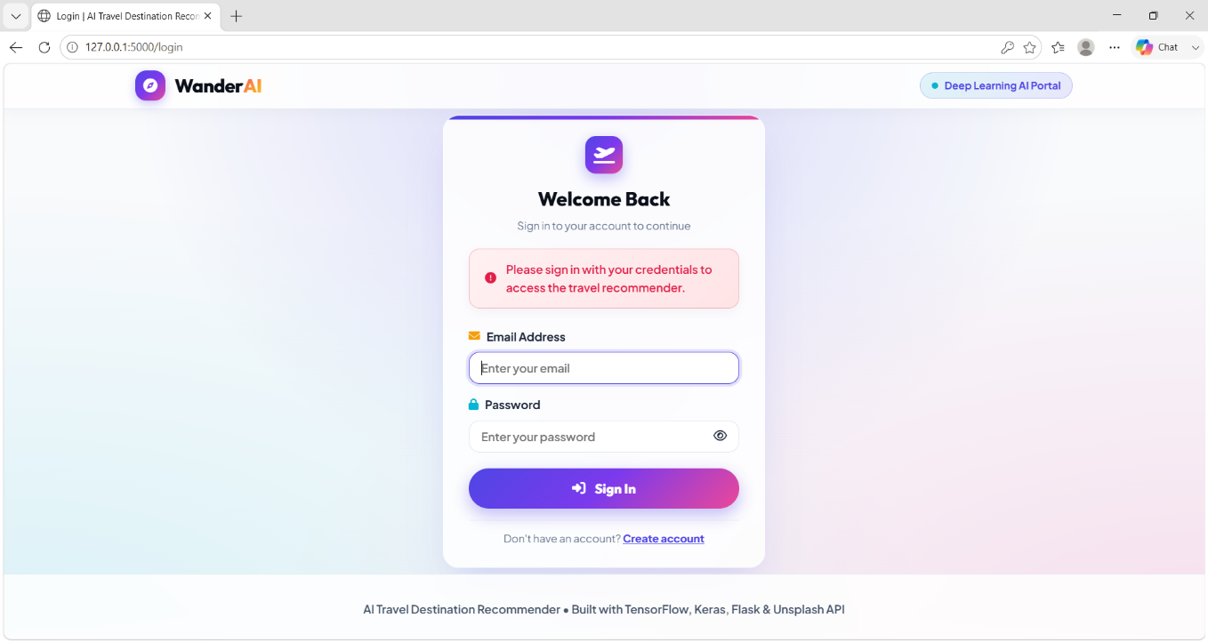
Figure 5: Output Screenshot — Login Screen

Figure 6: Output Screenshot — Travel Preference Input Form
Figure 7: Output Screenshot — Destination Recommendation Result
Figure 8: Output Screenshot — Confidence Score, Alternatives and Travel Guide

